# Simulation of distributions for the experiment on the relationship between the Illusion of Causality and the Foreign Language Effect

# 1. Fitting a Theoretical Distribution

To determine an appropriate Effect Size (ES) for detecting the difference between two groups exposed to a null contingency illusory condition (one in a native language – NL, and one in a foreign language – FL), we first examine the expected distribution of the dependent variable for the NL group. This distribution is based on data from a previous study (Dalla Bona & Vicovaro, 2024) that, like the current study, was conducted online using Psychopy (Peirce et al., 2019).

We then extend this analysis to consider the expected differences between the NL and FL groups. The data of the original study are available at: <https://osf.io/c26qa/files/osfstorage>.

Specifically, we focus on the control group, which was not exposed to any manipulations of perceptual features, in the null contingency illusory condition. Our objective is to identify which generative distribution most likely underlies the observed empirical data points.

To identify potential candidate distributions, we employ a Cullen and Frey graph that plots kurtosis against the square of skewness (Frey & Cullen, 1995). This visualization helps us assess the distributional characteristics of the data and select the most appropriate generative model.

## 1.1 Importing Data and Describing It

We begin by loading the data from the Excel file and filtering it to include only participants with valid responses (valido == "si"). The tempoistr (time spent in the experiment) variable is then converted to numeric format, and we exclude any rows where the time spent is less than 10 seconds, as this was an exclusion criterion in the previous experiment. Next, we extract the causal evaluation scores for participants in the control group who were exposed to the null contingency scenario (identified by gruppo == 1). These scores are stored in the vector_illusion variable.

# Reading the data from the Excel file  
library(readxl)  
  
data <- as.data.frame(read_xlsx("Dataframeclt_online.xlsx"))  
  
  
# Structure of the dataset  
str(data)

'data.frame': 249 obs. of 15 variables:  
 $ cp1 : chr "A" "A" "A" "B" ...  
 $ cp2 : num 1 2 3 4 5 6 7 8 9 10 ...  
 $ REF : num 1 2 3 5 6 7 8 9 10 11 ...  
 $ email : logi NA NA NA NA NA NA ...  
 $ sesso : chr "F" "F" "F" "M" ...  
 $ eta : num 24 24 22 27 25 23 22 23 30 30 ...  
 $ valido : chr "si" "si" "si" "si" ...  
 $ gruppo : num 3 2 1 2 1 4 4 3 4 3 ...  
 $ tempoistr : chr "33.7546" "33.2288" "67.6089" "138.8366" ...  
 $ tempotask : chr "347.3093" "336.9458" "328.1303" "265.2705" ...  
 $ tempovd : chr "10.4335" "10.8814" "9.2636" "44.5247" ...  
 $ tempocheck: chr "12.1336" "9.3648" "7.7313" "9.0483" ...  
 $ tempotot : chr "486.661" "434.2955" "469.9609" "537.1056" ...  
 $ vd : num 59 50 69 40 70 80 75 68 70 80 ...  
 $ check : num 1 6 1 7 2 6 5 1 6 1 ...

# Subset the first 209 rows  
data <- data[1:209,]  
  
# Filter data for valid responses  
data <- subset(data, data$valido == "si")  
  
# Convert 'tempoistr' to numeric and filter out fast responders   
#(time < 10 seconds)  
data$tempoistr <- as.numeric(data$tempoistr)  
data <- data[-c(which(data$tempoistr < 10)), ]  
  
# Extract causal evaluation scores for the control group  
vector_illusion <- data$vd[data$gruppo == 1]  
vector_general <- data$vd

The causal evaluation is treated as a metric (interval-like) variable, with scores ranging from 0 to 100. For the control group (N = 60), the distribution of the dependent variable is fairly spread out, with a mean of 58.58, a median of 63, and a standard deviation of 18.51. The range spans from a minimum of 16 to a maximum of 90, and 50% of the data fall between 50 and 73 (1st Quartile = 49.5, 3rd Quartile = 73). The distribution exhibits a moderate negative skew (skewness = -0.63), which may be partially attributable to the data being bounded between 0 and 100. Additionally, the distribution is slightly platykurtic (kurtosis = -0.45), indicating a flatter shape compared to a normal distribution.

To visualize this distribution, we use a combination of plots: the boxplot highlights the quartiles and potential outliers, the half-eye plot provides a kernel density estimate, and the dot plot emphasizes individual data points.

# View the length and summary of the vector  
length(vector_illusion)

[1] 60

summary(vector_illusion)

Min. 1st Qu. Median Mean 3rd Qu. Max.   
 16.00 49.50 63.50 58.58 73.00 90.00

# Calculate detailed descriptive statistics  
library(pastecs)  
round(stat.desc(vector_illusion, norm = TRUE), 2)

nbr.val nbr.null nbr.na min max range   
 60.00 0.00 0.00 16.00 90.00 74.00   
 sum median mean SE.mean CI.mean.0.95 var   
 3515.00 63.50 58.58 2.39 4.78 342.59   
 std.dev coef.var skewness skew.2SE kurtosis kurt.2SE   
 18.51 0.32 -0.63 -1.02 -0.45 -0.37   
 normtest.W normtest.p   
 0.95 0.01

# Load ggplot packages  
library(ggdist); library(ggthemes); library(ggplot2)  
  
library(ggokabeito) #Colorblind friendly palette  
  
# Visual representation  
ggplot(mapping = aes(y = vector_illusion, fill = factor(1))) +   
 scale_fill_okabe_ito( alpha = .9) +   
 stat_halfeye(adjust = 0.9, justification = -0.2, .width = 0,   
 point_colour = NA) +   
 geom_boxplot(width = 0.12, outlier.color = NA, alpha = 0.5) +   
 stat_dots(side = "left", justification = 1.1, binwidth = 1) +   
 labs(y = "Causal Evaluation", x = "") +   
 coord_flip() +   
 theme_bw() +   
 theme(legend.position = "none")

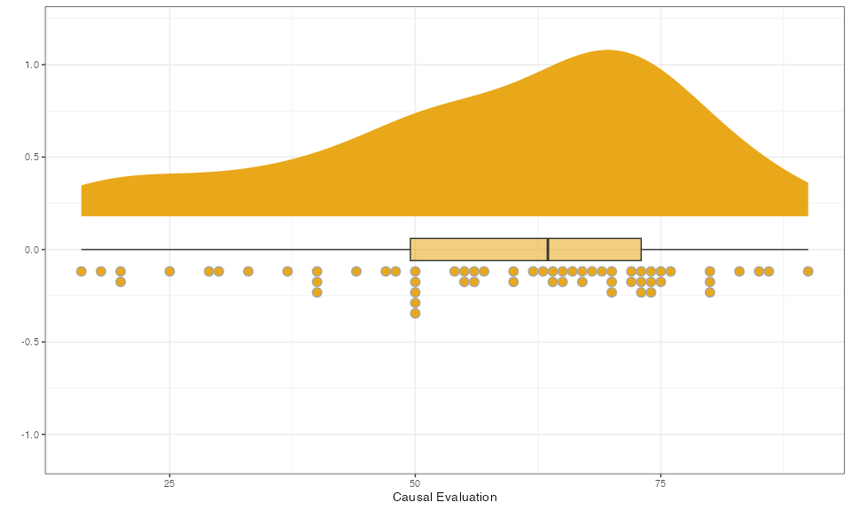

## 1.2 Generative Distributions

In this section, we aim to identify the distribution that best describes our sample data. To do so, we compare our data to various theoretical distributions using the Cullen and Frey graph. This graph plots kurtosis against the square of skewness (Frey & Cullen, 1995), allowing us to visually assess how well our data aligns with different distribution families.

The data are represented as a red point on the graph, indicating how closely the distribution resembles known distribution families. To enhance the analysis, we also include bootstrapped data (generated from the sample) to assess how the distribution holds up under resampling.

To generate the graph and perform the analysis, we use the fitdistrplus package. The following code fits the data to various distributions and plots the Cullen and Frey graph, treating the variable as discrete (assuming the random variable takes countable values).

# Generate the Cullen and Frey graph with bootstrapping (1000 resamples)  
library(fitdistrplus)  
  
descdist(vector_illusion, boot = 1000, discrete = TRUE)

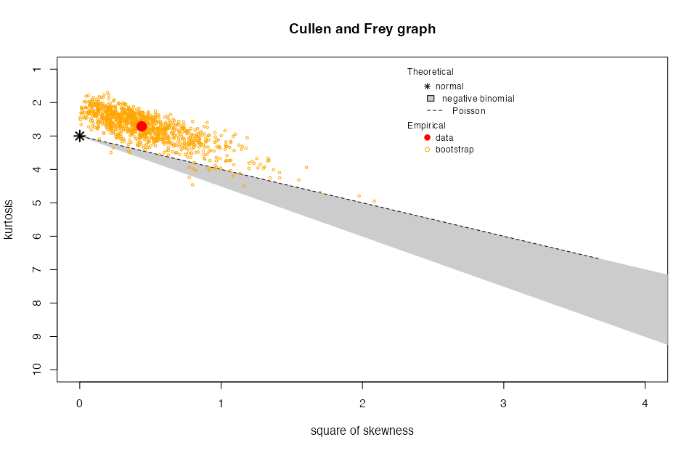

summary statistics  
------  
min: 16 max: 90   
median: 63.5   
mean: 58.58333   
estimated sd: 18.50908   
estimated skewness: -0.6617163   
estimated kurtosis: 2.710791

We consider two candidate distributions for the data: the Normal distribution and the Poisson distribution. To determine the most suitable model, we perform a series of diagnostic plots and statistical tests that compare the empirical distribution of the data against the theoretical distributions.

From these diagnostic plots, we observe that the Normal distribution fits the data better than the Poisson distribution. This observation is further confirmed by the goodness-of-fit tests, which indicate that the Normal distribution is the most probable model for our data. Specifically, the Akaike weight for the Normal distribution is approximately 1, suggesting that it is the best-fitting model.

It is important to note that the Normal distribution fitted to the data is truncated, particularly on the right-hand side. This truncation occurs because the mean of the distribution exceeds the median point of 50, and the data are constrained within the boundaries of 0 to 100. As a result, values that would typically fall outside the upper boundary are clipped, leading to negative skewness, especially in the left tail. Based on these observations, we assume that the truncated Normal distribution is the most appropriate generative distribution for further analysis.

# Fit distributions to the data  
fnorm <- fitdist(vector_illusion, "norm") # Fitting Normal distribution  
fpois <- fitdist(vector_illusion, "pois") # Fitting Poisson distribution  
  
plot.legend <- c("Normal", "Poisson")  
par(mfrow = c(2, 2))  
  
# Density comparison   
denscomp(list(fnorm, fpois), legendtext = plot.legend)  
  
# Q-Q plot comparison   
qqcomp(list(fnorm, fpois), legendtext = plot.legend)  
  
# CDF comparison   
cdfcomp(list(fnorm, fpois), legendtext = plot.legend)  
  
# P-P plot comparison   
ppcomp(list(fnorm, fpois), legendtext = plot.legend)

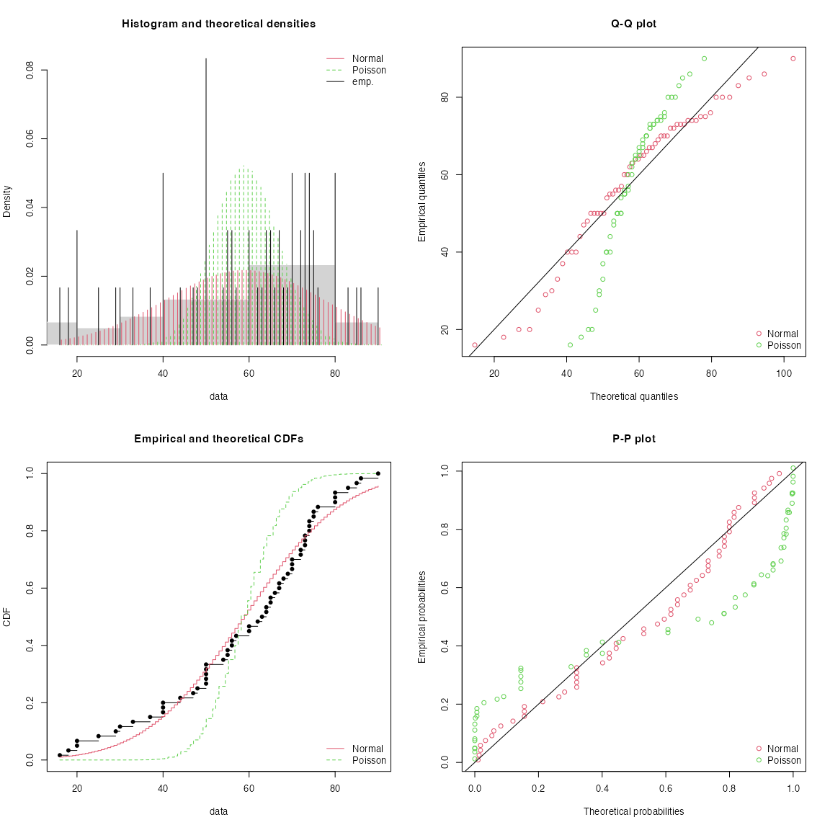

# Goodness-of-fit tests  
gofstat(list(fnorm, fpois), fitnames = c("Normal", "Poisson"))

Goodness-of-fit statistics  
 Normal Poisson  
Kolmogorov-Smirnov statistic 0.1160484 0.2933251  
Cramer-von Mises statistic 0.1692820 1.8065351  
Anderson-Darling statistic 1.0540738 30.3656046  
  
Goodness-of-fit criteria  
 Normal Poisson  
Akaike's Information Criterion 523.4556 743.5827  
Bayesian Information Criterion 527.6443 745.6771

# Akaike weights   
C <- gofstat(list(fnorm, fpois), fitnames = c("Normal", "Poisson"))  
  
AIC_W_pois <- exp(-1/2 * (C$aic[2] - C$aic[1])) /   
 (exp(-1/2 * (C$aic[1] - C$aic[2])) + exp(-1/2 * (C$aic[2] - C$aic[1])))  
  
AIC_W_norm <- exp(-1/2 * (C$aic[1] - C$aic[2])) /   
 (exp(-1/2 * (C$aic[1] - C$aic[2])) + exp(-1/2 * (C$aic[2] - C$aic[1])))  
  
as.numeric(AIC_W_norm); round(as.numeric(AIC_W_pois),3)

[1] 1

[1] 0

# 2. Simulating Approach to Estimate ES

In this section, we employ a simulation-based approach to estimate a meaningful ES. Specifically, we aim to generate simulated data from a theoretical distribution (the truncated Normal distribution) and hypothesize about the potential meaningful difference between two groups, namely NL (i.e., the control group) and FL (i.e., the treatment group).

## 2.1 Simulating the Distribution

To align with the characteristics of the observed data, for the simulations we use a truncated normal distribution bounded between 0 and 100.

We will use a custom function, based on the **qnorm** and **runif** functions, to generate truncated normal data.

By imposing boundaries on the simulated data, we truncate the distribution. This means that any data points that would normally fall outside the specified range (0 to 100) are trimmed. Consequently, truncation introduces skewness in the distribution, particularly when the mean is positioned closer to one of the boundaries. This behavior is expected when dealing with bounded data.

As truncation limits the spread of the data, when the mean of the distribution passed to the function is more extreme (i.e., closer to the boundaries) the standard deviation (SD) of the distribution is reduced.

# Generation from a "truncated" normal distribution  
tnorm_f <- function(n, mean, sd, a = 0, b = 100) {  
 qnorm(runif(n, pnorm(a, mean, sd), pnorm(b, mean, sd)), mean, sd)   
} # Truncated at 0 and 100 (a and b)  
  
# Using the truncated normal distribution  
set.seed(4234)  
x <- round(tnorm_f(length(vector_illusion), 58.58, 18.51))   
  
# Plot values  
ggplot(mapping = aes(x, fill = factor(1))) +   
 geom_histogram(binwidth = 10, color = "black") +  
 theme_bw() +   
 scale_fill_okabe_ito(order = 2) +  
 theme(legend.position = "none") +  
 labs(x = "Values", y = "Frequencies")

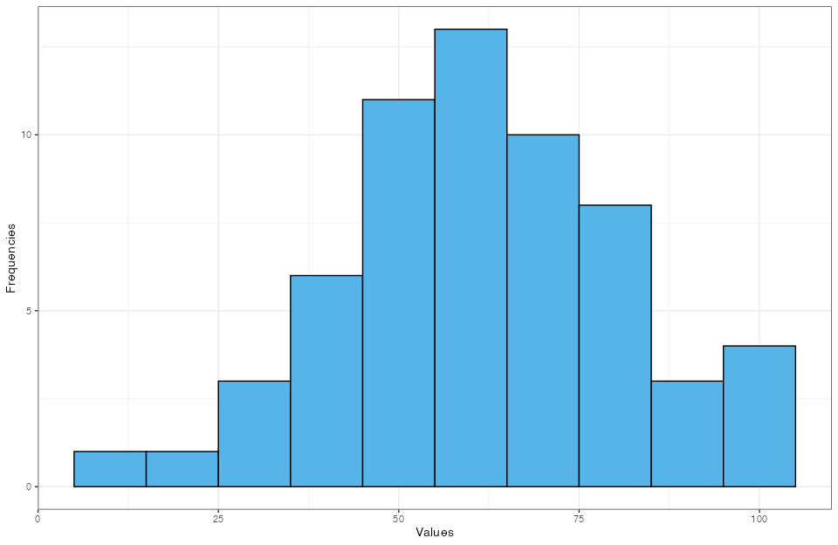

# Simulate with different means to observe the effects of truncation  
a <- round(tnorm_f(10e4, 50, 20)) # Mean = 50 (n=10000)  
b <- round(tnorm_f(10e4, 60, 20)) # Mean = 60 (n=10000)  
c <- round(tnorm_f(10e4, 70, 20)) # Mean = 70 (n=10000)  
d <- round(tnorm_f(10e4, 30, 20)) # Mean = 30 (n=10000)  
  
  
gga <- ggplot(mapping = aes(a, fill = factor(1))) +   
 geom_histogram(binwidth = 10, color = "black") +  
 theme_bw() +   
 scale_fill_okabe_ito(order = 3) +  
 theme(legend.position = "none") +  
 labs(x = "Values (mean = 50)", y = "Frequencies")  
  
ggb <-ggplot(mapping = aes(b, fill = factor(1))) +   
 geom_histogram(binwidth = 10, color = "black") +  
 theme_bw() +   
 scale_fill_okabe_ito(order = 4) +  
 theme(legend.position = "none") +  
 labs(x = "Values (mean = 60)", y = "Frequencies")  
  
ggc <-ggplot(mapping = aes(c, fill = factor(1))) +   
 geom_histogram(binwidth = 10, color = "black") +  
 theme_bw() +   
 scale_fill_okabe_ito(order = 5) +  
 theme(legend.position = "none") +  
 labs(x = "Values (mean = 70)", y = "Frequencies")  
  
ggd <-ggplot(mapping = aes(d, fill = factor(1))) +   
 geom_histogram(binwidth = 10, color = "black") +  
 theme_bw() +   
 scale_fill_okabe_ito(order = 6) +  
 theme(legend.position = "none") +  
 labs(x = "Values (mean = 30)", y = "Frequencies")  
  
gridExtra::grid.arrange(gga,ggb,ggc,ggd)

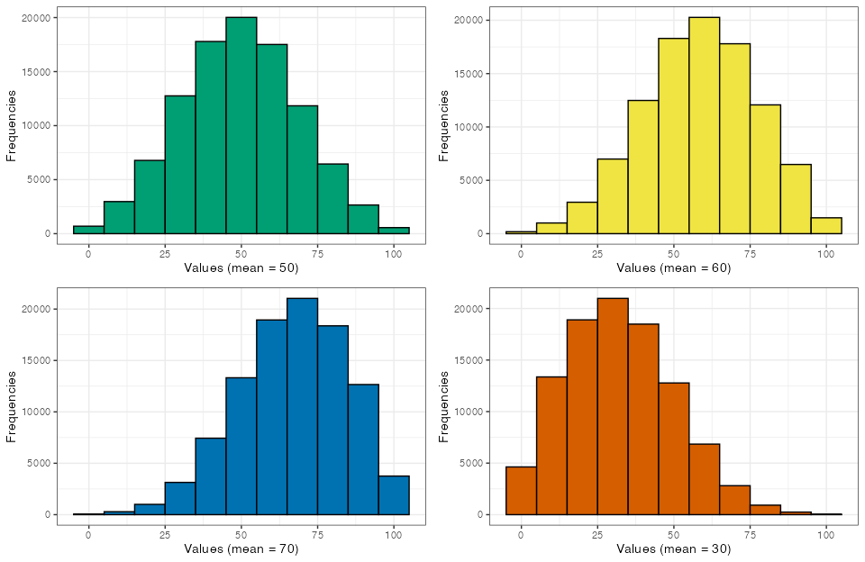

# Simulate with different means to observe the effects of truncation  
x <- round(tnorm_f(100000, 50, 20)) # Mean = 50  
y <- rnorm(100000, 50, 20) # Untruncated normal  
  
# Calculate means and SDs   
mean(x); sd(x)

[1] 49.93504

[1] 19.07987

mean(y); sd(y)

[1] 49.98902

[1] 19.91653

# Simulate with higher mean to observe the effect more clearly  
x <- round(tnorm_f(100000, 65, 20)) # Mean = 65  
y <- rnorm(100000, 65, 20) # Untruncated normal  
  
# Calculate means and SDs   
mean(x); sd(x)

[1] 63.28526

[1] 18.18063

mean(y); sd(y)

[1] 65.06018

[1] 19.9791

## 2.2 Comparisons

In this section, we compare how well the truncated normal distribution simulates the empirical data, relative to the normal distribution without boundaries. We visually examine the three distributions (empirical, normal, and truncated normal) and compute the overlap indices between the empirical data and the theoretical simulated distributions (with the same sample size). The overlap metric quantifies how much the distributions overlap, providing insight into how well each simulated distribution fits the empirical data.

From this analysis, we observe that the truncated normal distribution, with a inputted mean of 60 and a standard deviation of 20 (closely approximating the empirical mean of 58.58 and standard deviation of 18.51 of the original data – M = 58.97, SD = 18.70), provides a marginally better fit for the data compared to the normal distribution without boundaries. Nonetheless, we continue to use the truncated normal distribution, as we anticipate that, by approaching more extreme values for the mean, this simulation approach will even better capture the behavior of the data. Specifically, the truncated normal distribution allows us to more effectively model the data’s characteristics based on the positioning of the mean within the bounded range.

# Simulate data for normal and truncated normal distributions  
set.seed(4234)  
  
simulated_norm <- round(rnorm(1000000, mean(vector_illusion),   
 sd(vector_illusion)))   
mean(simulated_norm); sd(simulated_norm)

[1] 58.57679

[1] 18.51333

simulated_trunc <- round(tnorm_f(1000000, 60, 20))   
mean(simulated_trunc); sd(simulated_trunc)

[1] 58.96533

[1] 18.70319

# Plot the distributions   
empirical_df <- data.frame(value = vector_illusion, type = "Empirical")  
simulated_df <- data.frame(value = simulated_norm, type = "Simulated Norm")  
simulated_df1 <- data.frame(value = simulated_trunc,   
 type = "Simulated Trunc")  
  
combined_df <- rbind(empirical_df, simulated_df, simulated_df1)  
  
ggplot(combined_df, aes(x = value, col = type)) +  
 geom_density(alpha = 0.5) +   
 scale_color_okabe_ito() +  
 labs(title = "Empirical and Simulated Data Distributions",  
 x = "Value",  
 y = "Density") +  
 theme_bw() +   
 theme(legend.position = "top")

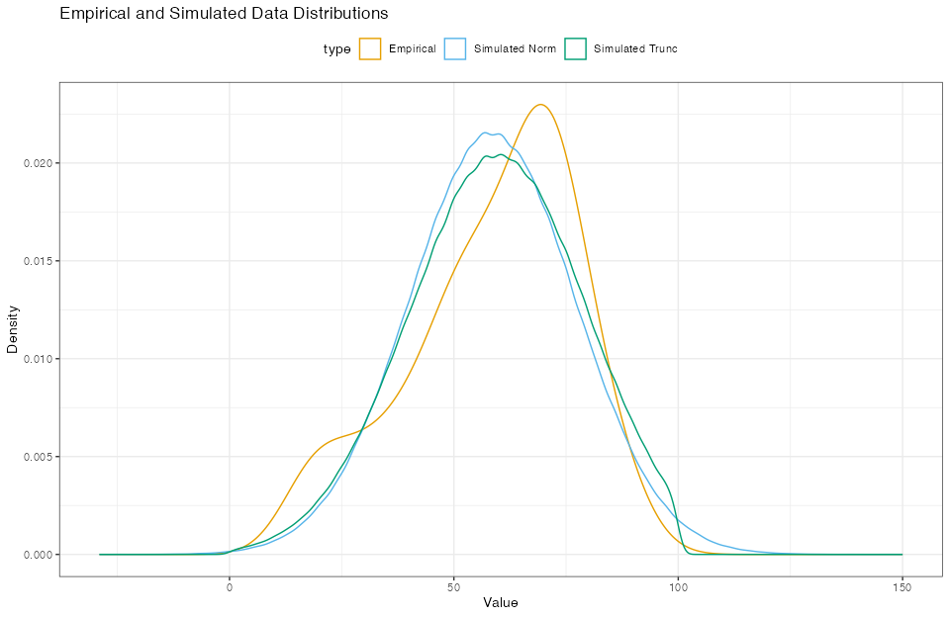

# Calculate overlap coefficient with normal distribution  
library(overlapping)  
  
overlap_norm_values <- rep(NA, 1000)  
for(i in 1:1000){  
 simulated_sample <- round(rnorm(length(vector_illusion), 58.58, 18.41))  
 overlap_norm_values[i] <- overlap(list(simulated_sample, vector_illusion),   
 type = "1")[1]  
}  
median(as.numeric(overlap_norm_values)); mean(as.numeric(overlap_norm_values))

[1] 0.863875

[1] 0.8617332

# Calculate overlap coefficient with truncated normal distribution  
overlap_trunc_values <- rep(NA, 1000)  
for(i in 1:1000){  
 simulated_sample <- round(tnorm_f(length(vector_illusion), 60, 20))  
 overlap_trunc_values[i] <- overlap(list(simulated_sample, vector_illusion),   
 type = "1")[1]  
}  
median(as.numeric(overlap_trunc_values)); mean(as.numeric(overlap_trunc_values))

[1] 0.8783599

[1] 0.8763157

## 2.3 Analysis prior

In the experiment by Dalla Bona and Vicovaro (2024), we observed that approximately 36% of participants tended to select Likert scale responses divisible by 10 (e.g., 20, 30, 40, 50, etc.), while about 50% of participants selected responses divisible by 5 (e.g., 20, 25, 30, 35, etc.).

# Causality evaluations divisible by 5 and by 10  
 sum(vector_general %% 5 == 0) / length(vector_general) *100

[1] 50.5

sum(vector_general %% 10 == 0) / length(vector_general) *100

[1] 36.5

This suggests that Likert scale points ending in 5 or 10 may act as anchor points for participants’ responses. This observation can give rise to a heuristic type of reasoning to elicit an analysis prior distribution of ES for our experiment: we can use these anchor points to model the mean difference between the two groups, assuming that a shift in causal evaluation — triggered by an FL manipulation — could lead participants to anchor their responses to lower key points on the scale.

Referring to the original study by Díaz-Lago and Matute (2019), the difference between the two groups in the first experiment was greater than 20 points (NL group M = 64.5, SD = 15.12; FL group M = 40.75, SD = 18.43), which we interpret as a shift of 4 or 5 anchor points (20–25 Likert points). In the second experiment, which is more similar to our upcoming study, the difference between the two groups was slightly less than 20 points (NL group M = 63, SD = 20.49; FL group M = 44.30, SD = 26.18), which we interpret as a shift of 3 or 4 anchor points (15–20 Likert points).

We must also account for the possibility that the estimated difference could be inflated due to a reduced sample size. Therefore, a reduction of 1 or 2 anchor points seems plausible.

We plan to create an analysis prior considering a minimum reduction of 1 anchor (5 points, which corresponds approximately to a 0.2 Cohen’s d effect size from meta-analysis) and a maximum shift of 4 anchors (20 points, corresponding approximately to a 1 Cohen’s d effect size from the original experiment). We will generate the means of the two groups using the interval between these two anchors (5 to 20 points, with a step size of 1). We will use the entire interval between anchors, as the mean reflects only a theoretical value.

We assume that the NL group mean will vary within a range of -5 to +5 points compared to the previously observed data. Additionally, we hypothesize that the FL group will exhibit greater variability not only due to a reduction in the mean of the truncated normal distribution but also because individuals in the FL group may show differing responses to the FL exposure. To account for this increased variability, we will simulate different FL group standard deviations, ranging from 20 to 25 (following an increase of approximately 5 points as in the original experiment), with a step size of 1.

Finally, we will store the results in a dataframe that includes Cohen’s d values, which will serve as prior knowledge on the expected effect size (ES) for future analyses. We will also store the updated mean parameterization for the FL group. In each simulation, the FL group’s mean parameter will be adjusted to ensure that the difference between the NL and FL group means is always at least the desired mean difference. This updated mean will be crucial for design analysis, as it ensures the simulation maintains the required mean difference and provides an accurate representation of the distributions for subsequent simulations.

This prior will serve as a reference for the analysis prior for a Bayes Factor Design Analysis (the density plot is shown in blue, with the classical “objective analysis prior” shown in red). It reflects the uncertainty about where we believe the true effect size lies, as the meta-analysis suggests a small effect size, whereas the original experiment suggests a large effect size.

Our belief is that the true effect size lies somewhere in between and this belief will be incorporated in the design analysis.

# Simulate with varying mean differences  
calculate_effect_size_TSD <- function(NLmean, NLsd, treatment_sd,   
 desired_diff = 10, n = 10000) {  
 # NL group with SD = 20  
 NLc_data <- round(tnorm_f(n, NLmean, NLsd))   
 # FL group with varying SD  
 FLc_data <- round(tnorm_f(n, NLmean - desired_diff, treatment_sd))  
   
 # Ensuring that the difference of means is at least the difference required  
 x <- 0  
 while (abs(mean(NLc_data) - mean(FLc_data)) <   
 (desired_diff - 0.04) &   
 abs(mean(NLc_data) - mean(FLc_data)) >   
 (desired_diff + 0.04)) {  
   
 if (mean(NLc_data) > mean(FLc_data)) {  
 x <- x + 0.05  
 FLc_data <- round(tnorm_f(n, NLmean - (desired_diff + x),   
 treatment_sd))  
 } else {  
 x <- x - 0.05  
 FLc_data <- round(tnorm_f(n, NLmean - (desired_diff + x),   
 treatment_sd))  
 }  
 }  
   
 # Cohen's d  
 d <- as.numeric(cohens_d(NLc_data, FLc_data, pooled_sd = TRUE)[1])  
   
 # Return the results and new parameters t  
 return(c(d, NLmean - (desired_diff + x),   
 mean(NLc_data), sd(NLc_data), NLmean,   
 mean(FLc_data), sd(FLc_data), treatment_sd))  
}  
  
# NL means (55 to 65)  
control_means <- seq(55, 65, by = 1)  
  
# FL SDs (20 to 25)  
treatment_sds <- seq(20, 25, by = 1)  
  
# NL SD   
control_sd <- 20  
  
# Vector of mean differences  
desired_diffs <- c(5:20)  
  
# Preparing vectors to store results  
mean1_var <- rep(NA, length(control_means) *   
 length(treatment_sds) * length(desired_diffs))  
mean1_true <- rep(NA, length(control_means) *   
 length(treatment_sds) * length(desired_diffs))  
mean2_var <- rep(NA, length(control_means) *   
 length(treatment_sds) * length(desired_diffs))  
mean2_true <- rep(NA, length(control_means) *   
 length(treatment_sds) * length(desired_diffs))  
sd1_var <- rep(NA, length(control_means) *   
 length(treatment_sds) * length(desired_diffs))  
sd2_var <- rep(NA, length(control_means) *   
 length(treatment_sds) * length(desired_diffs))  
cohen_var <- rep(NA, length(control_means) *   
 length(treatment_sds) *   
 length(desired_diffs))  
sd_true <- rep(NA, length(control_means) *   
 length(treatment_sds) * length(desired_diffs))  
DI <- rep(NA, length(control_means) *   
 length(treatment_sds) * length(desired_diffs))  
counter <- 1  
  
# Simulate for each combination  
for (mean_val in control_means) {  
 for (treatment_sd_val in treatment_sds) {  
 for (diff in desired_diffs) {  
 vector <- calculate_effect_size_TSD(mean_val,  
 control_sd,   
 treatment_sd_val,   
 desired_diff = diff,   
 n = 100000)  
 cohen_var[counter] <- vector[1]  
 mean1_true[counter] <- vector[3]  
 mean1_var[counter] <- vector[5]  
 mean2_true[counter] <- vector[6]  
 mean2_var[counter] <- vector[2]  
 sd1_var[counter] <- vector[4]  
 sd2_var[counter] <- vector[7]  
 sd_true[counter] <- vector[8]  
 DI[counter] <- diff  
   
 counter <- counter + 1  
 }  
 }  
}  
  
effect_size_analysisP <- data.frame(  
 NLmean = mean1_var,  
 NLmeantrue = mean1_true,  
 FLmean = mean2_var,  
 FLmeantrue = mean2_true,  
 NLsd = sd1_var,  
 FLsd = sd2_var,  
 d = cohen_var,  
 sd = sd_true,  
 diff=DI  
)  
  
# Cohen's d   
ggplot(effect_size_analysisP, aes(x = d)) +  
 geom_histogram(fill="darkorange", col="black") +  
 labs(y = "Frequencies", x = "Cohen's d") +  
 theme_bw()

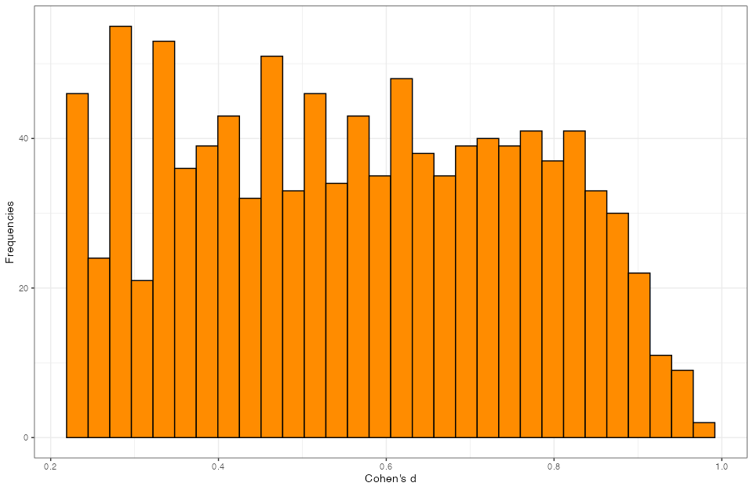

summary(effect_size_analysisP$d)

Min. 1st Qu. Median Mean 3rd  
Qu. Max.  
0.2198 0.3836 0.5624 0.5642  
0.7344 0.9668

# Priors (Our analysis prior and the Cauchy analysis prior)  
ggplot(effect_size_analysisP, aes(x = d)) +  
 geom_density(fill="blue", alpha=.4, col="darkblue") +  
 stat_function(fun = dt, args = list(df=1), lty="dashed", col="red") +  
 xlim(c(0,2)) +  
 labs(x = "Cohen's d", y = "Density") +  
 theme_bw()

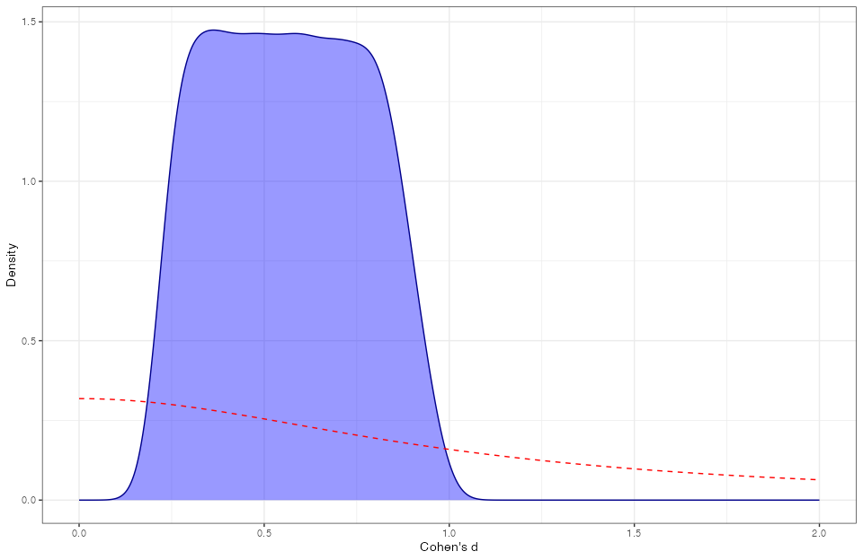

save(effect_size_analysisP, file="Effsize.Rda")

Our analysis prior under H1 can be described as a uniform (min = .22, max = .96), but we think that a personalized function could better describe the smoothness of the empirical distribution tails. For this reason, we came up with the following formula, normalized so that the area under the curve is equal to 1, and the .95 probability lies between the two inflection points (.2 and .9):

$f\left(x\right)=\left(\frac{1}{1+e^{−40\left(x−0.2\right)}}+\frac{1}{1+e^{35\left(x−0.9\right)}}−1\right)⋅\frac{10}{7}$

The analytical formula will be used as the analysis prior under H1, whereas the empirical distribution will be used as the design prior under which are going to sample data to calculate the necessary sample size for the experiment.

Our analysis prior under H0 is that there are no difference between means (i.e., ES is equal to 0).

#Comparison with a Uniform distribuion  
descdist(effect_size_analysisP$d, boot = 1000)

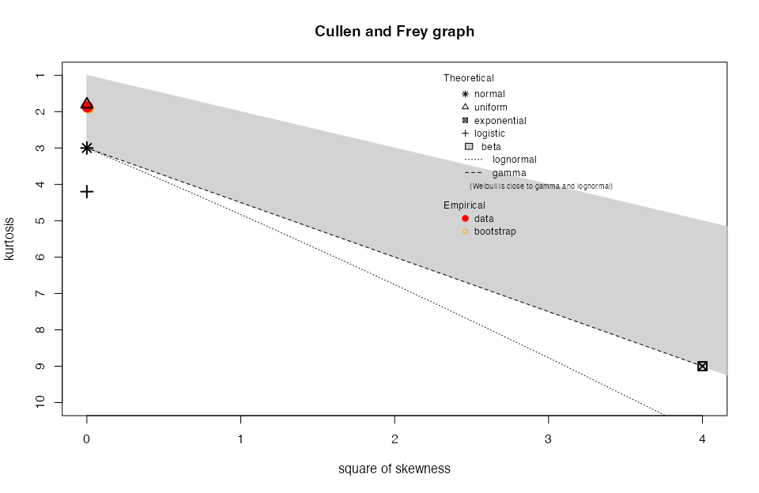

summary statistics  
------  
min: 0.2197644 max: 0.9667542   
median: 0.5623741   
mean: 0.5641723   
estimated sd: 0.2008705   
estimated skewness: 0.05674132   
estimated kurtosis: 1.86834

# Analysis prior analytic formula  
analysis_priors <- function(x, lower = 0.2, upper = .9, steepness = 35) {  
 ((1 / (1 + exp(-40 * (x - lower))) + 1 /   
 (1 + exp(steepness * (x - upper)))) - 1) * (10 / 7)  
}  
  
#Area under the curve between 0 and 1  
round(integrate(analysis_priors, 0, 1)$value,2)

[1] 1

#Area under the curve between .2 and .2  
round(1 - (integrate(analysis_priors, -10, .2)[[1]] +   
 integrate(analysis_priors, .9, 10)[[1]]), 2)

[1] 0.95

# Showing the analytical function and the empirical distribution  
delta_values <- seq(-2, 2, length.out = 1056)  
  
analysis_prior <- ((1 / (1 + exp(-40 * (delta_values - .22))) + 1 /   
 (1 + exp(35 * (delta_values - .9)))) - 1) /   
 (7 / 10)  
  
data <- data.frame(delta = delta_values,   
 analysis_prior = analysis_prior)  
  
ggplot(effect_size_analysisP, aes(x = d)) +  
 geom_density(fill="darkorange", alpha=.4, col="darkorange") +  
 geom_line(aes(x = data$delta, y = data$analysis_prior),   
 color = "blue3", size = 1) +  
 geom_vline(xintercept = .2, lty="dashed", col="blue3") +  
 geom_segment(aes(x = .2, xend = .9, y = 3, yend = 3), col="blue3") +  
 geom_segment(aes(x = 0, xend = 0, y = 0, yend = 3),   
 col="darkred", lty="dashed") +  
 annotate("text", x = .55, y = 3.1,   
 label = "inflection distance p ~ .95") +  
 geom_vline(xintercept = .9, lty="dashed", col="blue3") +  
 xlim(c(0, 2)) +  
 labs(x = "Cohen's D", y = "Density") +  
 theme_bw()

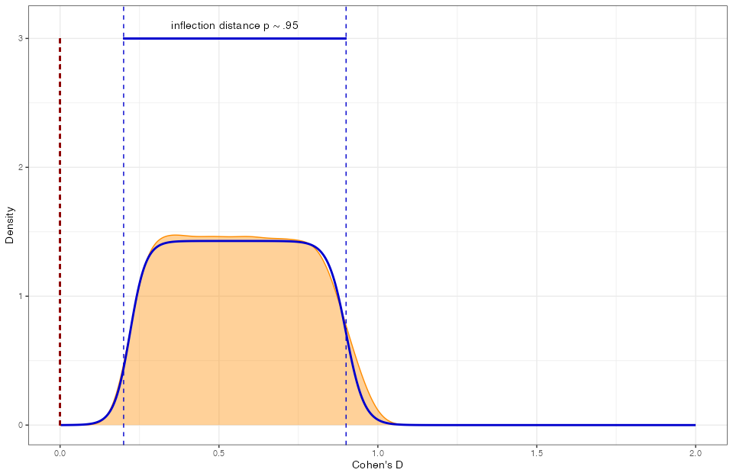

Arnold, J. B. (2024). *Ggthemes: Extra themes, scales and geoms for ’ggplot2’*. <https://CRAN.R-project.org/package=ggthemes>

Auguie, B. (2017). *gridExtra: Miscellaneous functions for "grid" graphics*. <https://CRAN.R-project.org/package=gridExtra>

Barrett, M. (2024). *Ggokabeito: ’Okabe-ito’ scales for ’ggplot2’ and ’ggraph’*. <https://github.com/malcolmbarrett/ggokabeito>

Ben-Shachar, M. S., Lüdecke, D., & Makowski, D. (2020). Effectsize: Estimation of effect size indices and standardized parameters. *Journal of Open Source Software*, *5*(56), 2815. <https://doi.org/10.21105/joss.02815>

Dalla Bona, S., & Vicovaro, M. (2024). Does perceptual disfluency affect the illusion of causality? *Quarterly Journal of Experimental Psychology*, *77*(8), 1727–1744. <https://doi.org/10.1177/17470218231220928>

Delignette-Muller, M. L., & Dutang, C. (2015). Fitdistrplus: An r package for fitting distributions. *Journal of Statistical Software*, *64*(4), 1–34. <https://doi.org/10.18637/jss.v064.i04>

Díaz-Lago, M., & Matute, H. (2019). Thinking in a foreign language reduces the causality bias. *Quarterly Journal of Experimental Psychology*, *72*(1), 41–51. <https://doi.org/10.1177/1747021818755326>

Frey, H. C., & Cullen, A. C. (1995). *Distribution development for probabilistic exposure assessment* (Vol. 11, p. 95).

Grosjean, P., & Ibanez, F. (2024). *Pastecs: Package for analysis of space-time ecological series*. <https://CRAN.R-project.org/package=pastecs>

Kay, M. (2024). Ggdist: Visualizations of distributions and uncertainty in the grammar of graphics. *IEEE Transactions on Visualization and Computer Graphics*, *30*(1), 414–424. <https://doi.org/10.1109/TVCG.2023.3327195>

Masked Citation. (n.d.). *Masked Title*.

Pastore, M., Alaimo Di Loro, P., Mingione, M., & Calcagni, A. (2022). *Overlapping: Estimation of overlapping in empirical distributions*. <https://CRAN.R-project.org/package=overlapping>

Peirce, J., Gray, J. R., Simpson, S., MacAskill, M., Hochenberger, R., Sogo, H., Kastman, E., & Lindelov, J. K. (2019). PsychoPy2: Experiments in behavior made easy. *Behavior Research Methods*, *51*, 195–203. <https://doi.org/10.3758/s13428-018-01193-y>

Wickham, H. (2016). *ggplot2: Elegant graphics for data analysis*. Springer-Verlag New York. <https://ggplot2.tidyverse.org>

Wickham, H., & Bryan, J. (2023). *Readxl: Read excel files*. <https://CRAN.R-project.org/package=readxl>